**MA2 – Mems based packaged Accelerometer module**

The MA2 is a small, low power, complete 3-axis accelerometer with signal conditioned voltage outputs. The product measures acceleration with a minimum full-scale range of ±3 g. It can measure the static acceleration of gravity in tilt-sensing applications, as well as dynamic acceleration resulting from motion, shock, or vibration. Bandwidths can be selected to suit the application, with a range of 0.5 Hz to 500 Hz for the X, Y and the Z axis.

**FEATURES**

3-axis sensing

Small, low profile package

14 mm × 14 mm × 10 mm

Low power: 350 μA (typical)

Single-supply operation: 1.8 V to 3.6 V

10,000 g shock survival

Excellent temperature stability

BW adjustment per axis

The output signals are analog voltages that are proportional to acceleration. The accelerometer can measure the static acceleration of gravity in tilt-sensing applications as well as dynamic acceleration resulting from motion, shock, or vibration.

Rather than using additional temperature compensation circuitry, innovative design techniques ensure that high performance is built in to the MA2. As a result, there is no quantization error or nonmonotonic behavior, and temperature hysteresis is very low (typically less than 3 mg over the −25°C to +70°C temperature range).

**Specifications**

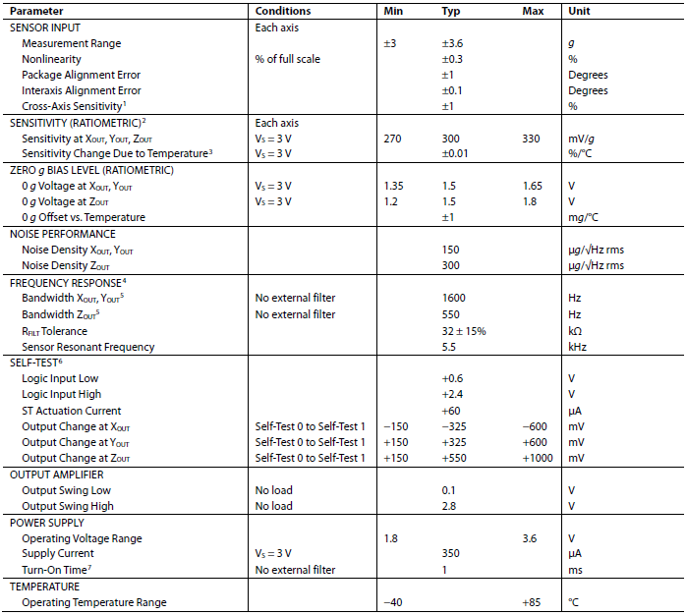

**Absolute Maximum Ratings**

Stresses above those listed under Absolute Maximum Ratings may cause permanent damage to the device. This is a stress rating only; functional operation of the device at these or any other conditions above those indicated in the operational section of this specification is not implied. Exposure to absolute maximum rating conditions for extended periods may affect device reliability.

